Terry Devereux

NU Data Science Bootcamp

Assignment #1

Excel Kickstarter Data

1. What are three conclusions we can make about Kickstarter campaigns given the provided data.
   1. “Theatre” is the most popular category of Kickstarter campaigns and “Plays” are the most popular sub-category or Kickstarter campaigns.
   2. 53.11% of Kickstarter Campaigns are successful in getting funded, however it varies greatly by the type of campaign. Music is the most likely category to be successful (79.41% success rate), while food is the most like to fail (72.16% failure rate). When looking at the sub-category there are several types that have never failed or never succeeded.
   3. Kickstarter campaigns are least likely to be launched in December and are least likely to succeed in obtaining their funding goal if they are launched in December.
2. The data does not provide a conversion into a common currency for each campaign. This makes our average donation column and metric unusable across the various countries and currencies the campaigns are funded in. The data we have spans several years, so any attempt at converting all of the data to USD would require converting each campaign’s currency at historic exchange rates. Since we do not have that data, we would be unable to easily identify the aggregate average donation of all Kickstarter campaigns and it would be difficult to analyze any country by country trends in terms of funding. We also do not have any data on the people groups who are creating the campaigns. There is no easy way to determine if some of these campaigns are repeats, done by the same people/group, or are evolutions of previous campaigns. This prevents us from understanding if some people are more successful at Kickstarter campaigns, or if prior successful campaigns lead to future successful campaigns (or vice versa).
3. The tables and graphs can be converted to show success/failure/canceled rates:

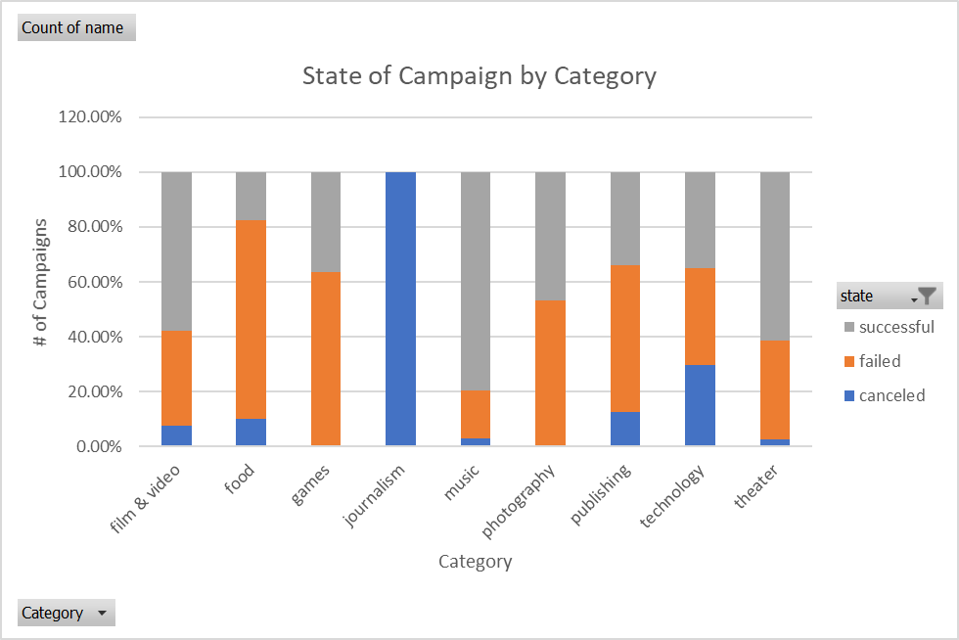

|  |  |  |  |  |
| --- | --- | --- | --- | --- |
| **Row Labels** | **canceled** | **failed** | **successful** | **Grand Total** |
| film & video | 7.69% | 34.62% | 57.69% | 100.00% |
| food | 10.31% | 72.16% | 17.53% | 100.00% |
| games | 0.00% | 63.64% | 36.36% | 100.00% |
| journalism | 100.00% | 0.00% | 0.00% | 100.00% |
| music | 2.94% | 17.65% | 79.41% | 100.00% |
| photography | 0.00% | 53.18% | 46.82% | 100.00% |
| publishing | 12.66% | 53.59% | 33.76% | 100.00% |
| technology | 29.67% | 35.50% | 34.83% | 100.00% |
| theater | 2.70% | 36.01% | 61.29% | 100.00% |
| **Grand Total** | **8.59%** | **37.65%** | **53.76%** | **100.00%** |

We can also show the success rate by country:

|  |  |  |  |  |  |
| --- | --- | --- | --- | --- | --- |
| **Row Labels** | **canceled** | **failed** | **live** | **successful** | **Grand Total** |
| AT | 0.00% | 33.33% | 16.67% | 50.00% | 100.00% |
| AU | 18.92% | 55.41% | 0.00% | 25.68% | 100.00% |
| BE | 0.00% | 50.00% | 0.00% | 50.00% | 100.00% |
| CA | 11.64% | 43.84% | 0.68% | 43.84% | 100.00% |
| CH | 50.00% | 33.33% | 0.00% | 16.67% | 100.00% |
| DE | 5.66% | 50.94% | 0.00% | 43.40% | 100.00% |
| DK | 28.57% | 42.86% | 0.00% | 28.57% | 100.00% |
| ES | 4.76% | 42.86% | 0.00% | 52.38% | 100.00% |
| FR | 18.52% | 37.04% | 7.41% | 37.04% | 100.00% |
| GB | 4.14% | 33.94% | 1.32% | 60.60% | 100.00% |
| HK | 33.33% | 66.67% | 0.00% | 0.00% | 100.00% |
| IE | 13.33% | 26.67% | 6.67% | 53.33% | 100.00% |
| IT | 10.34% | 65.52% | 0.00% | 24.14% | 100.00% |
| LU | 0.00% | 0.00% | 0.00% | 100.00% | 100.00% |
| MX | 8.33% | 66.67% | 25.00% | 0.00% | 100.00% |
| NL | 19.05% | 66.67% | 4.76% | 9.52% | 100.00% |
| NO | 0.00% | 71.43% | 0.00% | 28.57% | 100.00% |
| NZ | 33.33% | 41.67% | 0.00% | 25.00% | 100.00% |
| SE | 23.81% | 42.86% | 0.00% | 33.33% | 100.00% |
| SG | 0.00% | 0.00% | 0.00% | 100.00% | 100.00% |
| US | 8.46% | 36.11% | 1.09% | 54.34% | 100.00% |
| **Grand Total** | **8.48%** | **37.19%** | **1.22%** | **53.11%** | **100.00%** |

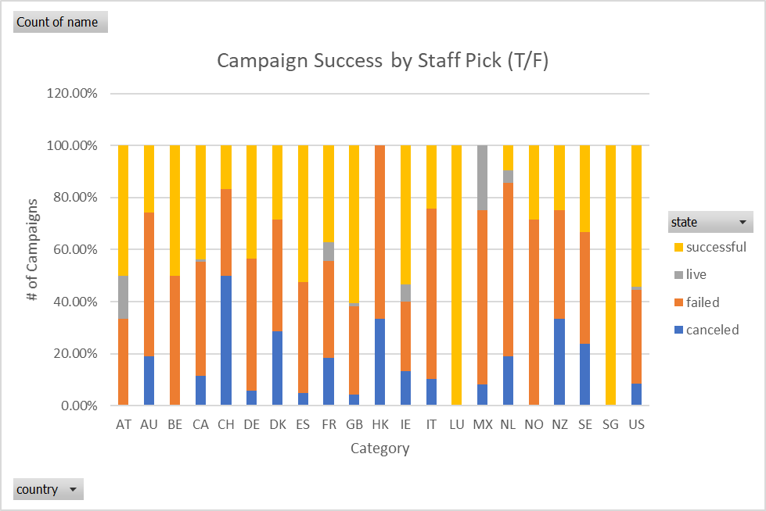

We can also look at the success of campaigns that are “Staff Picks” and compare that to those that were not:

